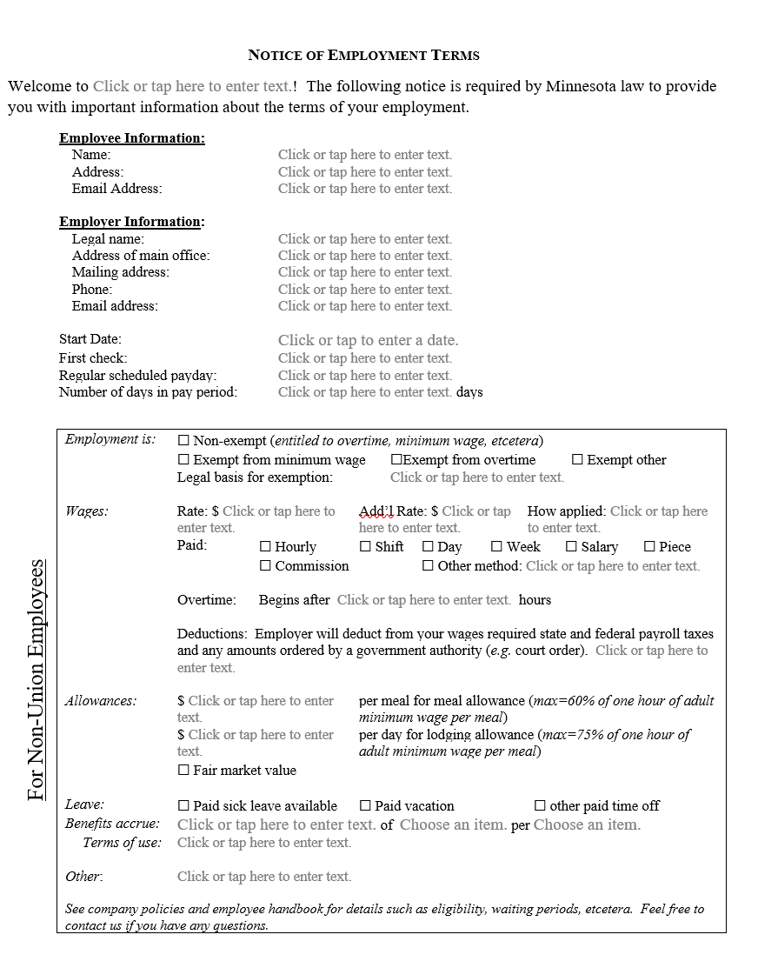
Required by Minn Stat § 181
Name of your business
Day of the week, then # of days in payperiod (commonly 7)
Start of employment or re-employment
Full legal name
Only required if employer is crediting the allowance toward a wage (Mn Rule 5200.0060 & 00700).
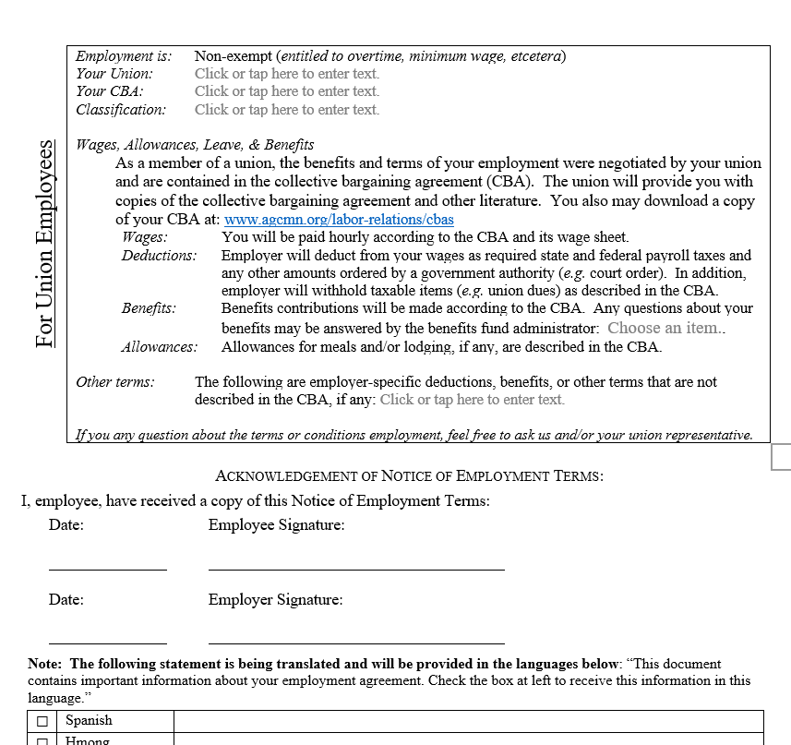
Eg. PTO given, wages above scale, etc.
2 copies—one for your files & one to give employee
DLI is translating this and we will update the form
AGC-Mn has posted the CBAs to provide this link
Eg, foreperson, journeyperson, apprentice, pre-apprentice; and, if applicable, percent vested
Name & local number of union that employee is a member
Which CBA covers the employee (include Highway or building, & area if applicable)

